BLOG WRITING

1. Go to www.blogger.com

2. Enter your Google Email and password into the Sign In box on the right side of the screen.

3. Click Sign In

Optional: If you do not want your name on your blog, click Switch to a limited Blogger Profile

4. Confirm Profile by clicking the Continue to Blogger button at the bottom of the screen.

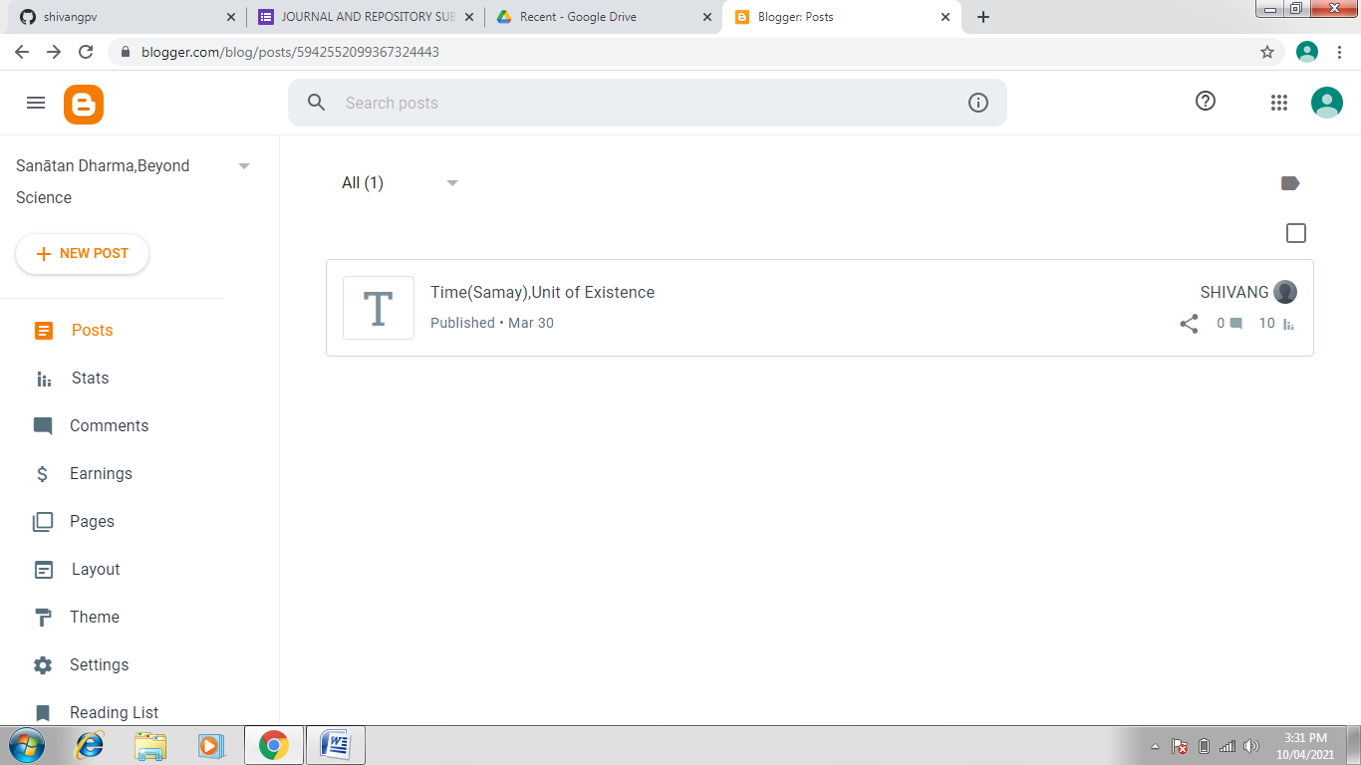

1. Click the New Blog button. The Create a New Blog window should appear.

2. Type in a title for your blog in the Title box

3. Type in a short address that relates to your blog's title in the Address box.

Important! If the address is already taken you will see a yellow box with an exclamation point. If the address is available, you will see a blue box with a check mark.

4. Select a template from the options provided by clicking on one. When a template is selected, it will have a blue box around it.

You must select a default template for now, but you will be able to customize it later.

5. Click Create Blog button.

